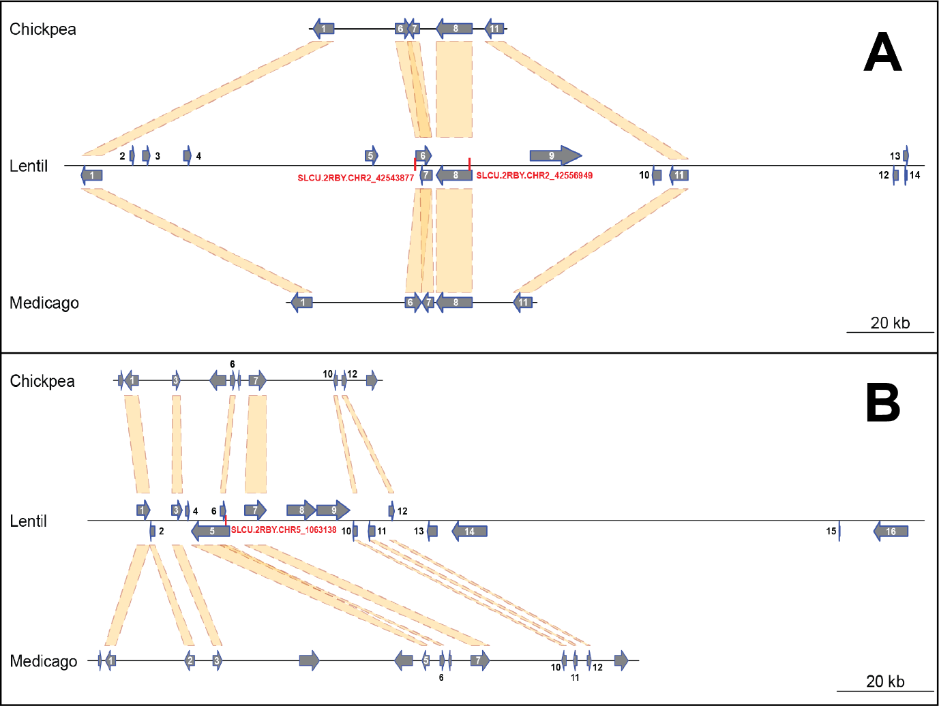

**Possible Supplementary Figure.** Diagram of a 290 kb region of lentil chromosome 2 (A) and a 215 kb region of lentil chromosome 5 (B) containing the relevant SNPs SLCU.2RBY.CHR2_42543877, SLCU.2RBY.CHR2_42556949 and SLCU.2RBY.CHR5_1063138 (highlighted in red). The syntenic regions in chickpea and Medicago genomes are also shown for comparison. The length of the relevant interval for each chromosome was calculated according to the SNP position ± chromosome-specific linkage disequilibrium decay. Numbers over or besides each gene correspond to those shown in Supplementary Table 2.